SmartLabs Announces all new service for Set Top Box design.

Designing products that fit your customers needs and expectations.

25 August 2016, Moscow — SmartLabs, a leader in the development of solutions for interactive TV and high-end set-top boxes, launches a new service to design customer premises equipment (CPE.)

With 8 years experience in the global pay TV market, the company has gained vast expertise, and uses it to continuously improve and enhance its own STB range. SmartLabs has delivered more than two million STBs to the markets of Eastern and Western Europe and North America.

Over the past two years, our international, in-house design team, have created a totally new lineup of devices for IPTV, OTT and hybrid networks with several stunning form factors.

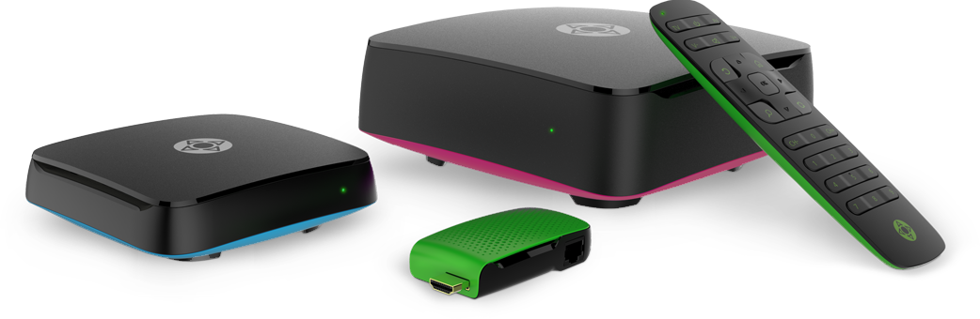
The new designs include a compact and a full-scale case as well as a stick design, an "invisible" STB and case variants for DVB hybrid and matching remote controls.

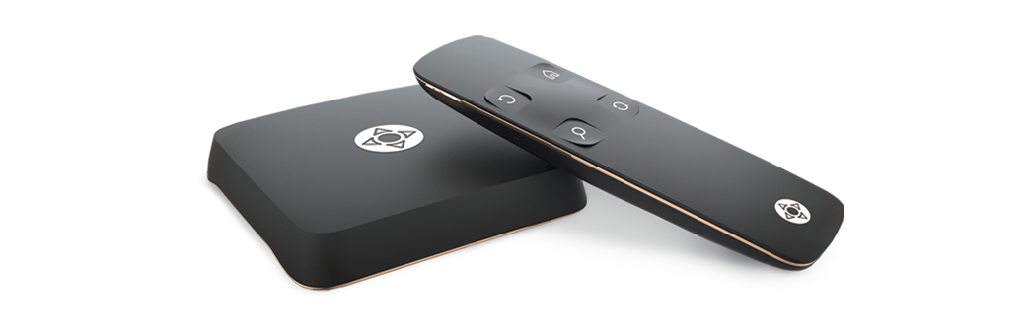
The centerpiece of our updated portfolio is an elegant premium-class case and remote control styled for discreet luxury.

SmartLabs' expertise in set-top box design is now available to third-party manufacturers, agencies and operators. The aesthetic and technical parameters of each model are designed to fit component set, customer expectations and brand values. Special attention is given to selecting the right quality materials and components to meet the customer’s requirements.

Our Design team will be with you every step of the way, from initial discussion through to mass manufacture, ensuring each bespoke product is brought to life in a timely and efficient way.

"We believe that our team's expert skills in innovative development are highly demanded by operators worldwide and can help ambitious companies to achieve their goals. Elaborate and appealing STB design is core to efficient interaction with the end user, contributing to the overall success of the manufacturer's or operator's market strategy. Based on our knowledge, skills and expertise, we are ready to develop custom products from scratch to fully meet the customer needs and end user expectations," SmartLabs CEO Mikhail Grachev says.

